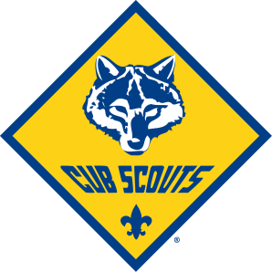
Cub Scout
Class B uniform order form
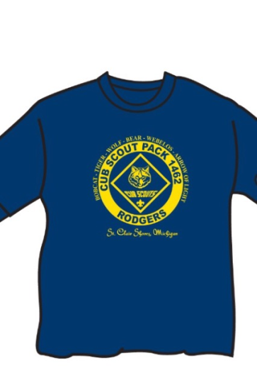
Class B shirts are shirts parents and Scouts can wear on Pack outings when full
Class A uniforms are not required.

Sizes Available: Youth S-M-L-XL Adult S-M-L-XL Adult 2XL-3xl-4xl
$8.00 $8.00 $10.00
Quantity | Size (please indicate Youth or Adult) | Amount Paid $$

Scouts Name__________________ Phone #_______________________

Den_________________________

